Al Hirani - AH45675

Kyle Grier – Kmg2969

EE 422C – Assignment 3 (Shopping Cart)

Unique Course Number: 16165 (TA: Jo)

**Deliverables**

**Analysis:** In this program, there will be 5 classes, a driver, a super class named Item, and three sub derived classes of Item: Groceries, Electronics, and Clothing. All sub derived classes have a calculate price method as well as a print attribute method which take into account certain attributes when completing the methods. A set of transactions is listed in a file for which the program will access and pull in line-by-line. Each line is then sorted through to differentiate between which kind of operation is needed to be done and with what type of item. Such operations include inserting into the shopping cart, deleting all instances of a certain item with a certain name from the shopping cart, updating the quantity of certain item from the shopping cart, searching for the number of a certain item in the shopping cart, and printing all that is in the shopping cart. If there is any bad data not following how the data should be inputted, an error message is outputted to the console and the process of sorting through the data should continue with the next line. Certain things to keep in mind are the facts that fragile electronics and perishable groceries must have premium shipping, increasing the price of the item(s), and that certain states have no taxes for electronics.

**IPO Model:**

Input:

* Operation
* Category of item (Applicable to Insert Operation)
* Name of item (Applicable to all operations except print)
* Price of Item (Applicable to Insert Operation)
* Quantity of Item (Applicable to Insert & Update Operation)
* Weight of item (Applicable to Insert Operation)
* Fragile/Not Fragile (Applicable only to Electronics)
* Perishable/Not Perishable (Applicable only to groceries)
* Shipping State (Applicable only to Electronics)

Process:

* An operation will first be specified and confirmed to be error free
* Then, depending on Operation, a certain number of inputs are inputed to another method where it is then parsed through and passed to other methods to complete tasks, such as:
  + Making new items and inserting into array list
  + Updating quantities
  + Searching for certain item
  + Deleting certain item

Output:

* An output is output when search, delete, update, or print are called
  + Print outputs all items’ attributes and final total of cart
  + Other methods output that operation has been done and what has been done to the shopping cart
  + **Design:** A system level Use Case Diagram

Clothing **is a** Item

Electronics **is a** Item

Groceries **is a** Item

Driver – Shopping Cart

Customer

Print

Delete

Update

Search

Insert

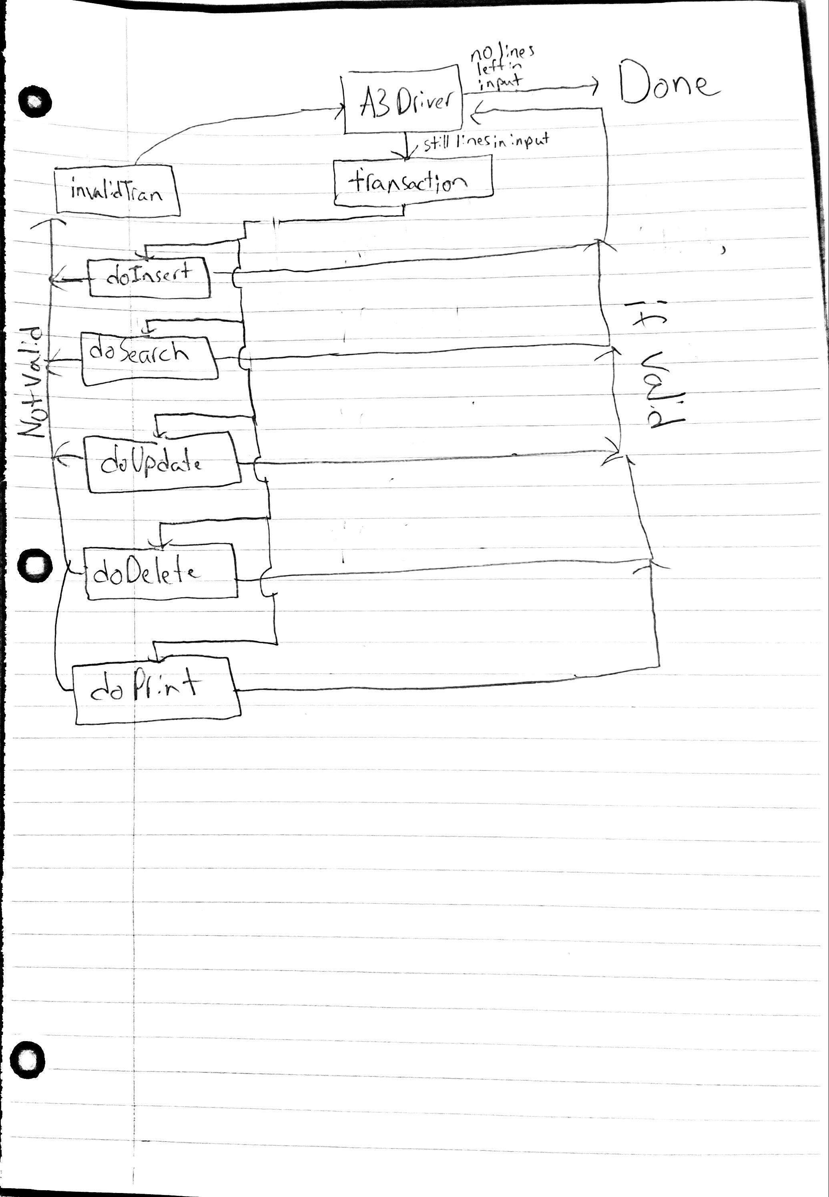

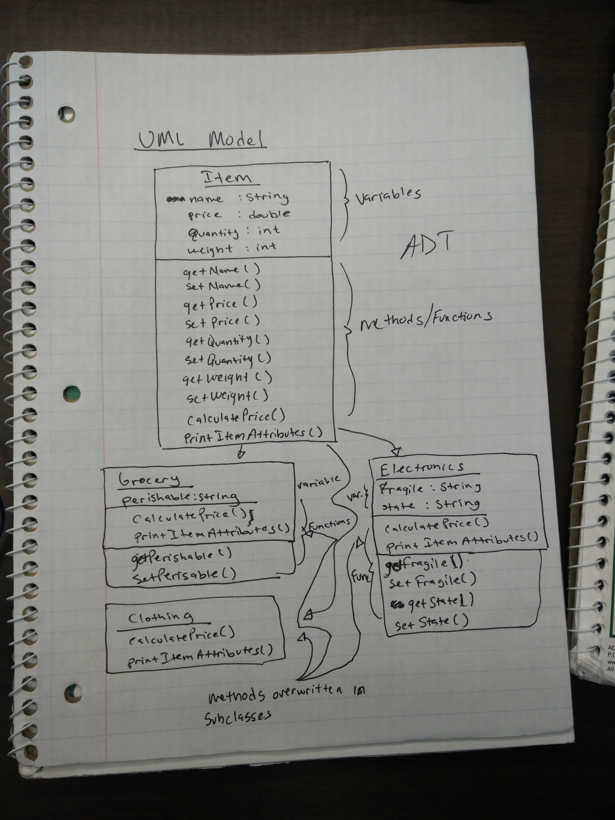

**PseudoCode:**

while there is a line in input file:

case insert:

case grocery:

parse rest of transaction data

put in shopping cart arraylist

case electronic:

parse rest of transaction data

put in shopping cart arraylist

case clothing:

parse rest of transaction data

put in shopping cart arraylist

case search:

find and print number of instances of name in a shopping cart

case update:

adjust quantity of a certain item in shopping cart

case delete:

remove all instances of an item in shopping cart

case print:

print the required info from all objects in shopping cart

case error:

print the line in text file where error occurs

end while